Software engineering for big data analaysis

CSA-1035

EXP NO: 30

30. Draw the flowchart that uses Raptor, how to reverse a given String. If the string is "hello" then, the output should be "olleh". We can use this concept to check the palindrome. Because the palindrome string will have the same value even after we reverse it

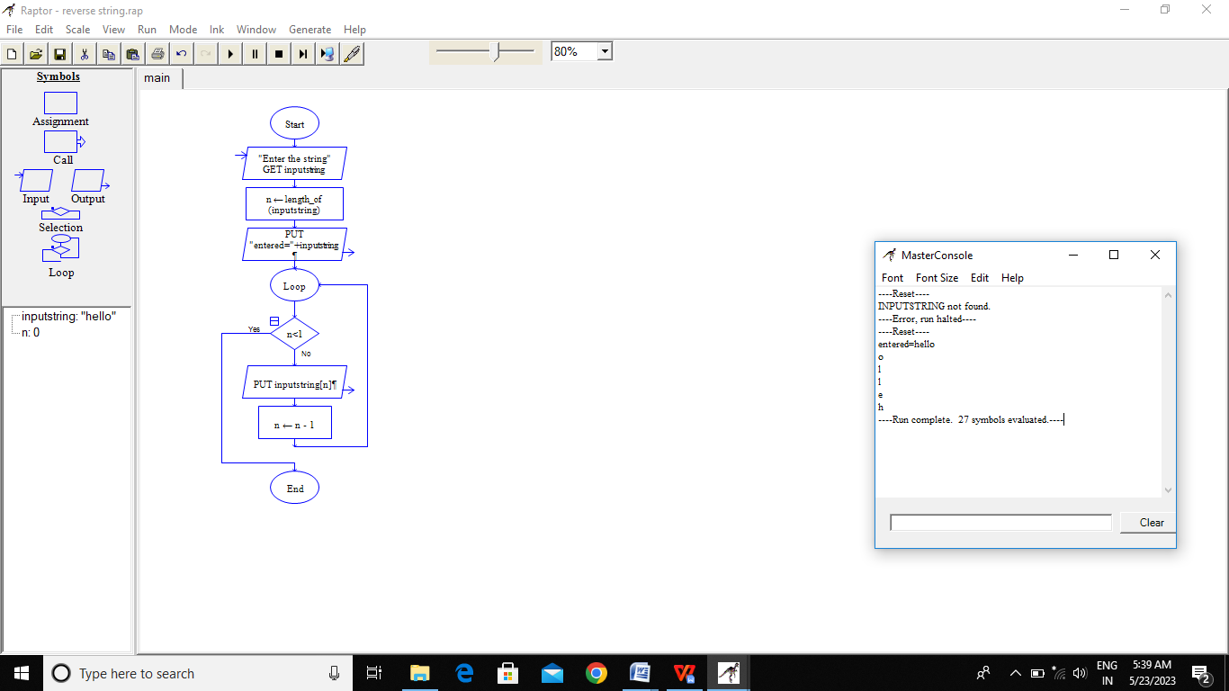

RESULT:-

BY Using Raptor for the reverse string is verified successfully